CALL FOR CODE: PRAYUDH


SUBJECT : DISASTER RESILIENCY

TEAM MEMBERS :
-SAHIL AHUJA
-ARGHO DAS
-DEVJYOTI MODAK

GETTING STARTED WITH IBM CLOUD:
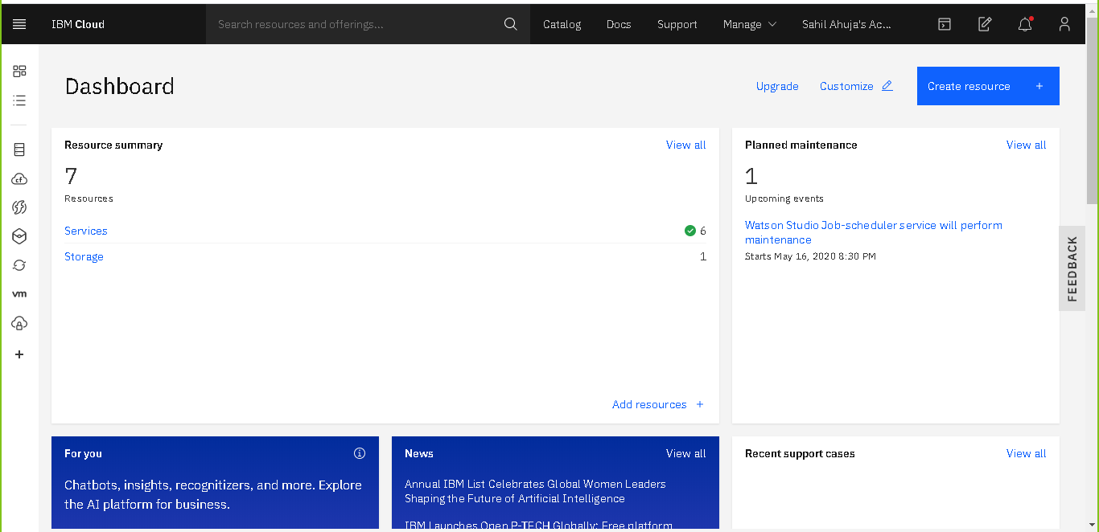
Fig: The following picture represents the dashboard page of IBM Cloud after we logged in

Step 1: Login with your IBM account credentials .Welcome to the dashboard of IBM Watson.

Step 2: Login with your IBM account credentials, you will be redirected to the IBM Cloud Dashboard page.

Launch Watson Assistant:

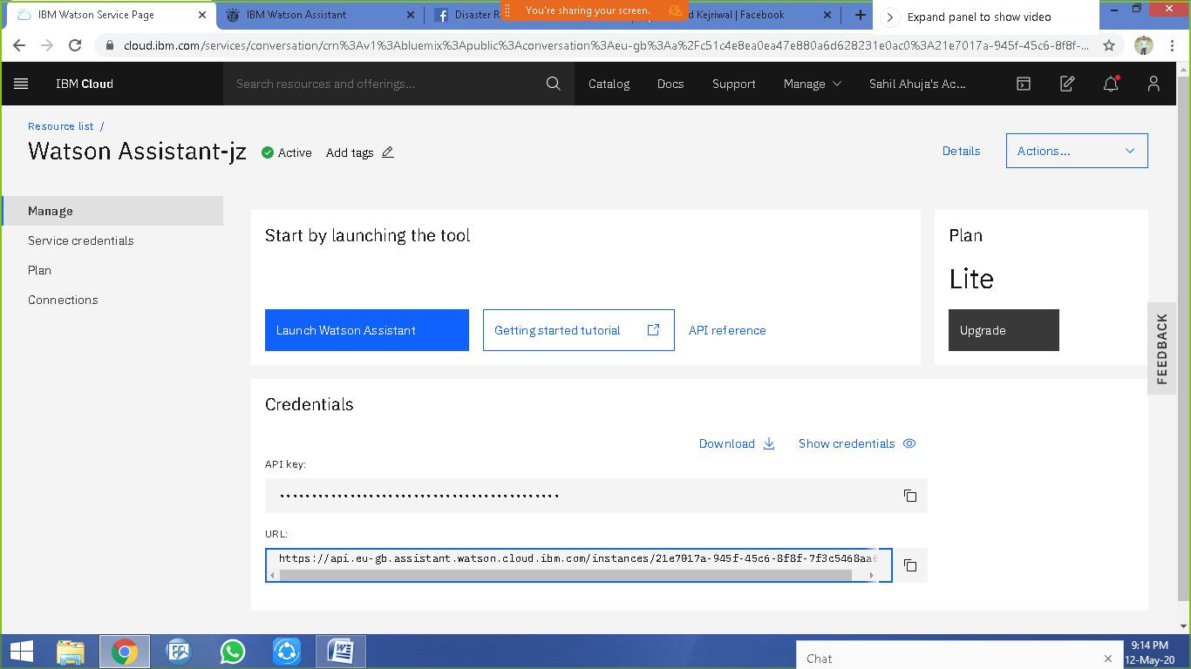

Step : Launch Watson Assistant.

INTEGRATION OF ASSISTANT:
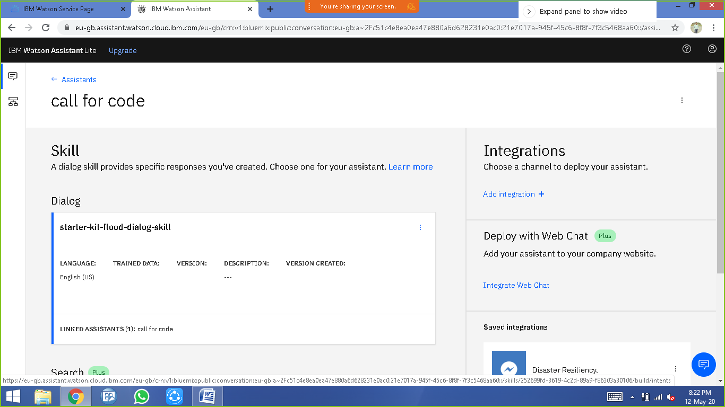

Step 1: In the first step for the creation of our chatbot, we created an assistant named Call For Code.

Step 2: After that, our assistant is created. Now we have created a dialog skill, we imported a json file named starter-kit-flood-dialog-skill .For the dialog skill, we already had a json file containing all the intents, entities and dialogs.

Intents Declaration:
Our Chatbot contains the following intents as shown in the picture which contains intents about various natural calamities like flood, cyclone and earthquake.

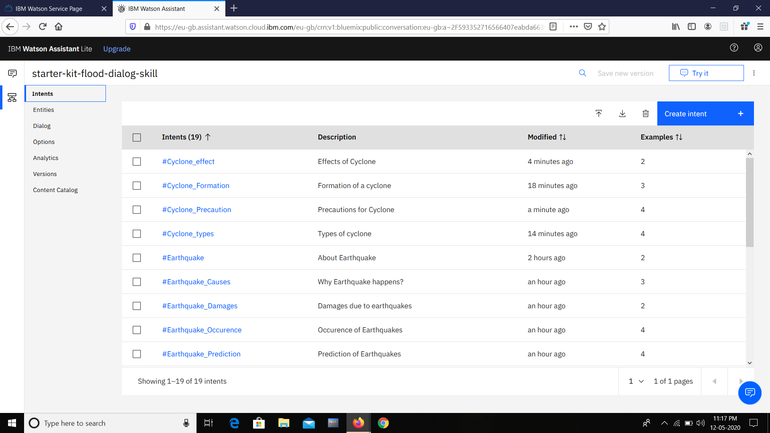

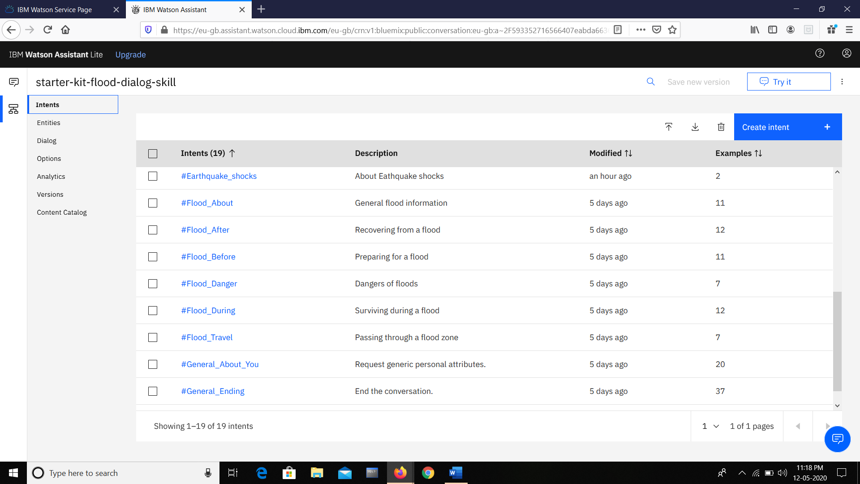
Dialog –
Our Chatbot contains the following dialogs which will be respond as per the user's intents that will be detected.

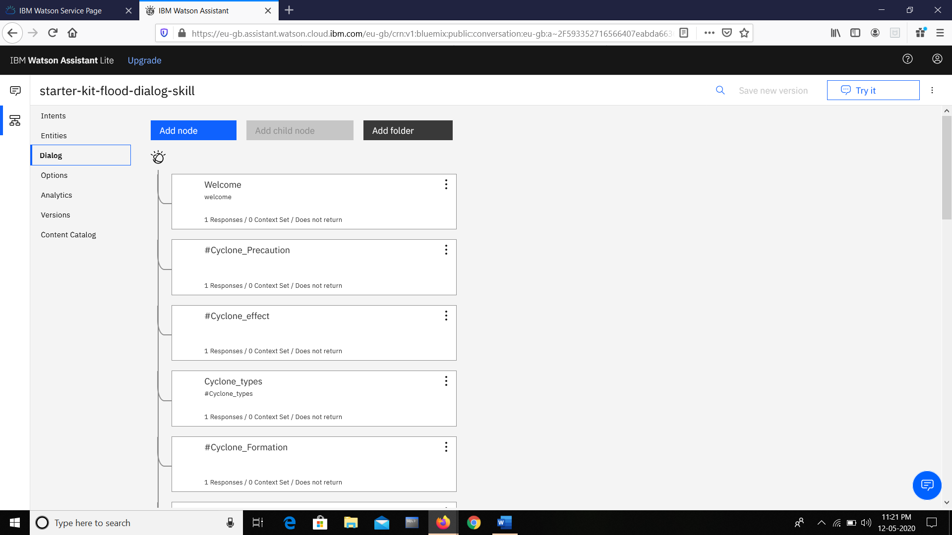

These are the dialogs for the intents of Cyclone.

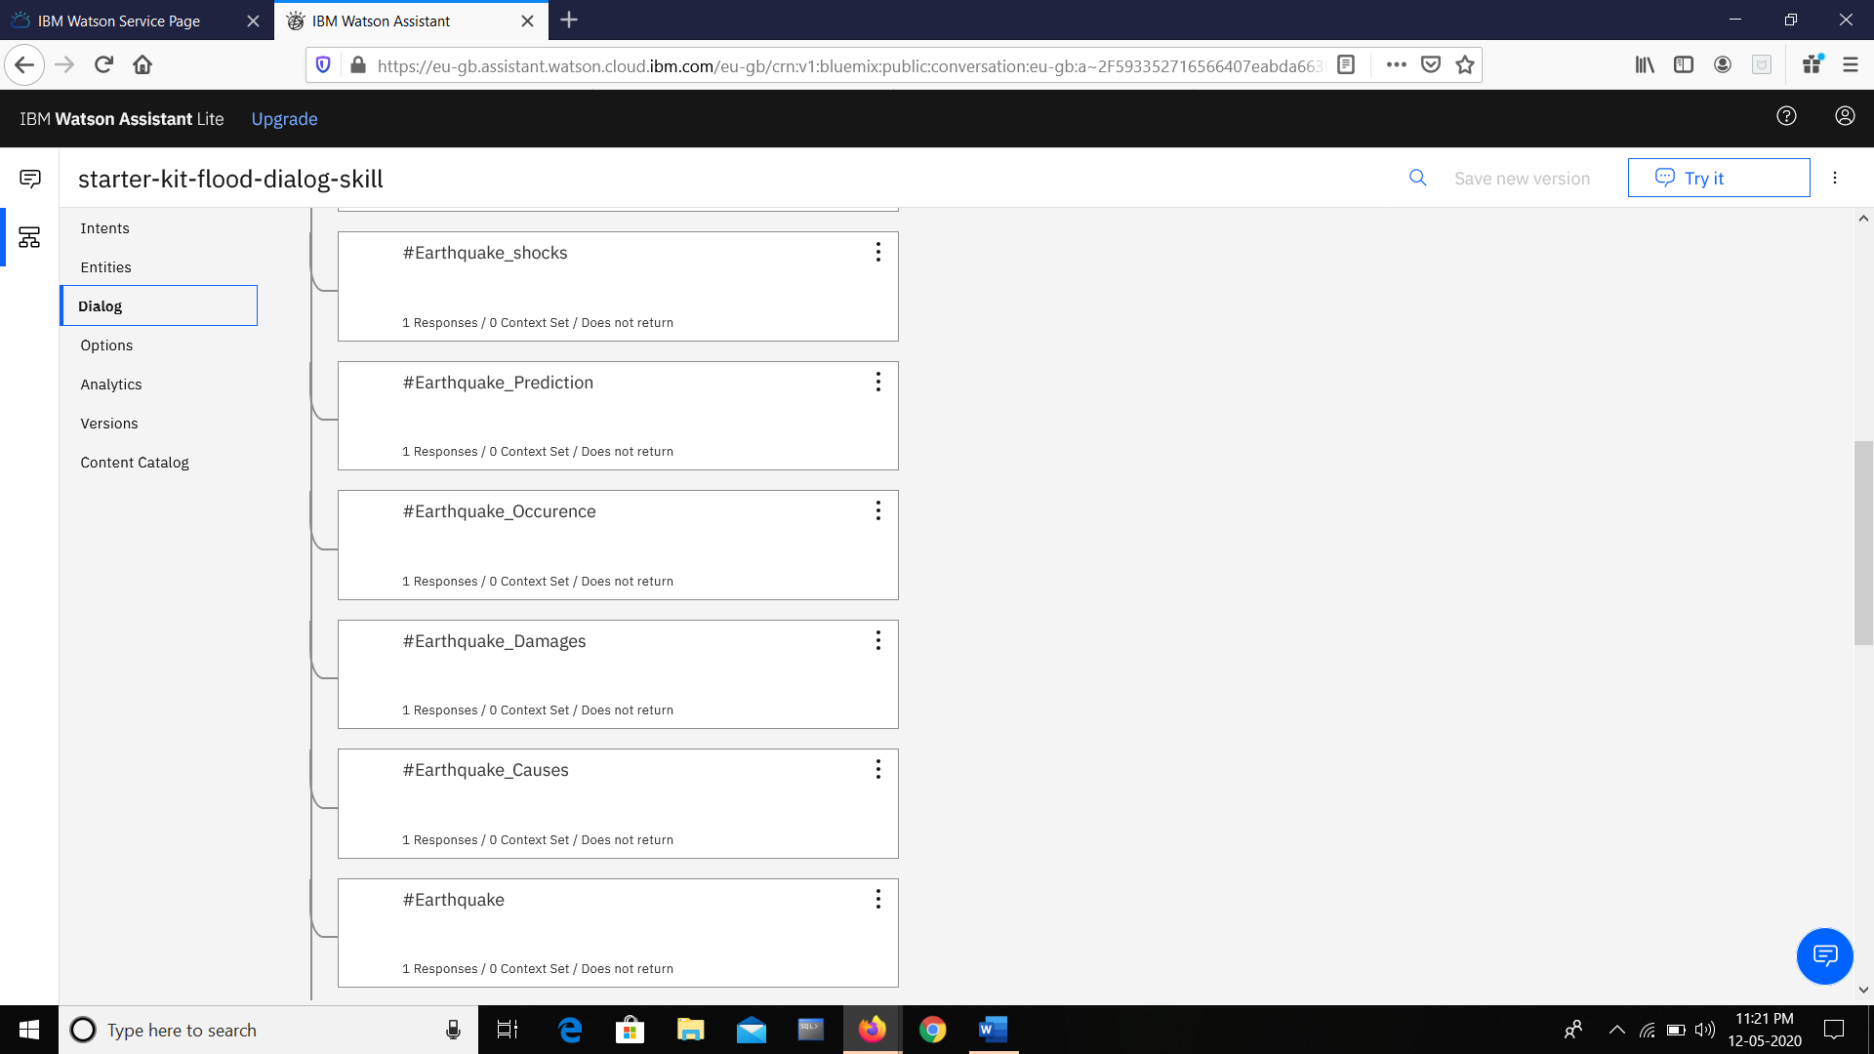
These are the dialogs for the intents of earthquake
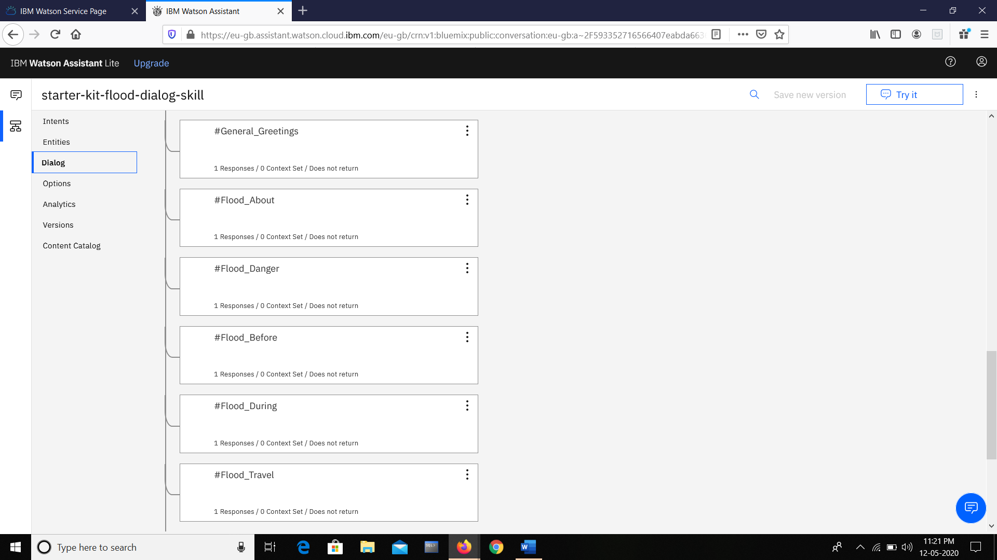

These are the dialogs for the intents of flood.
Try it out panel :

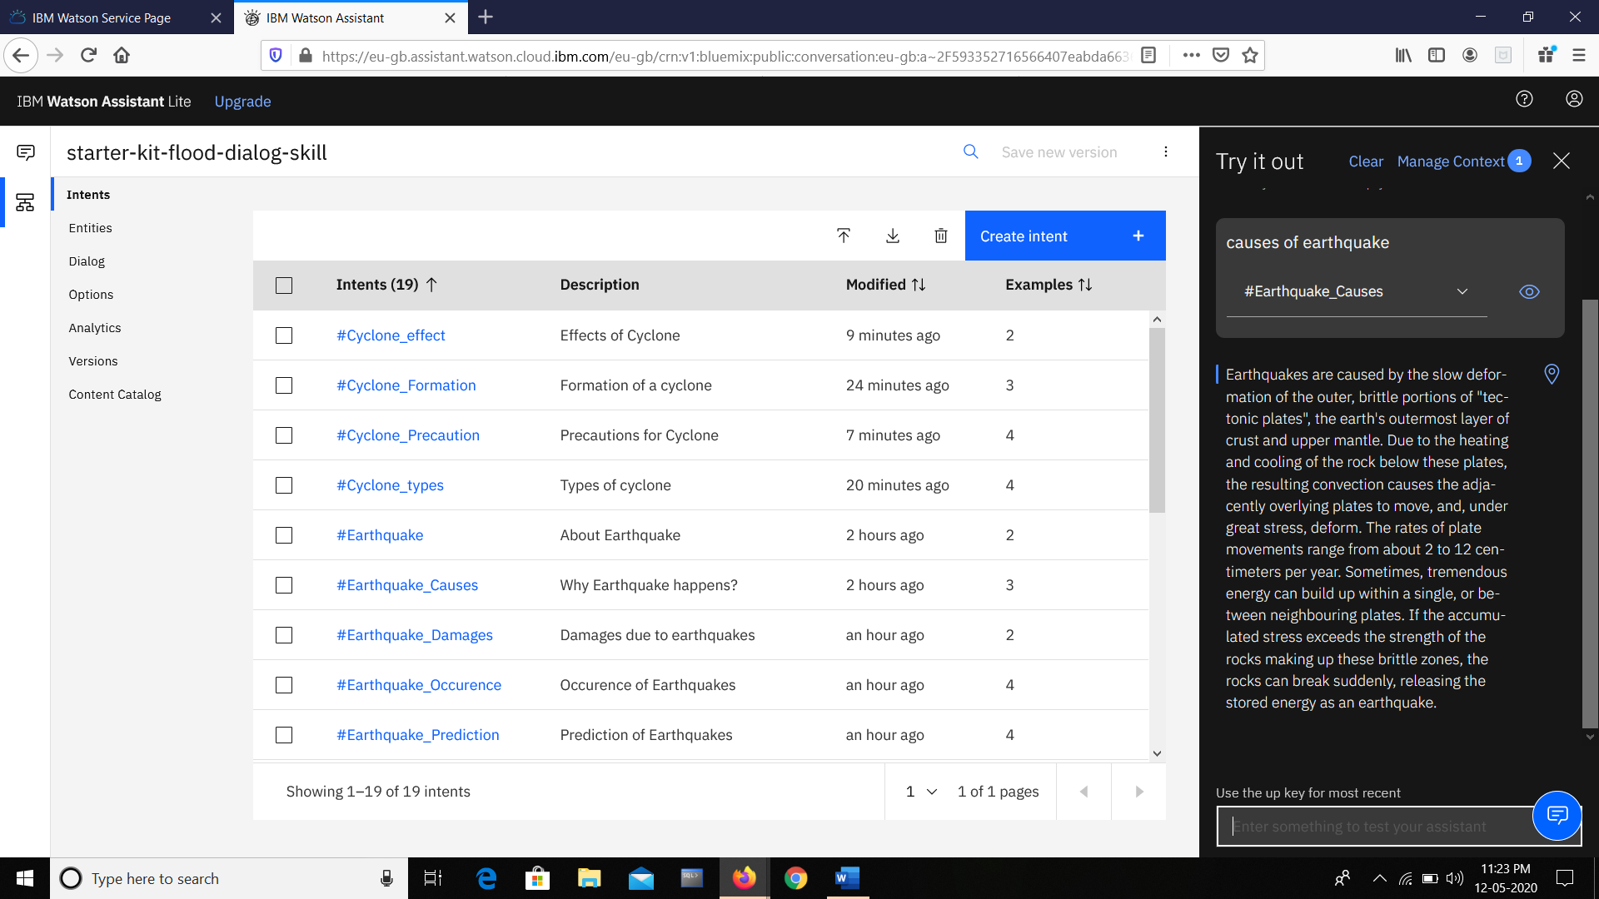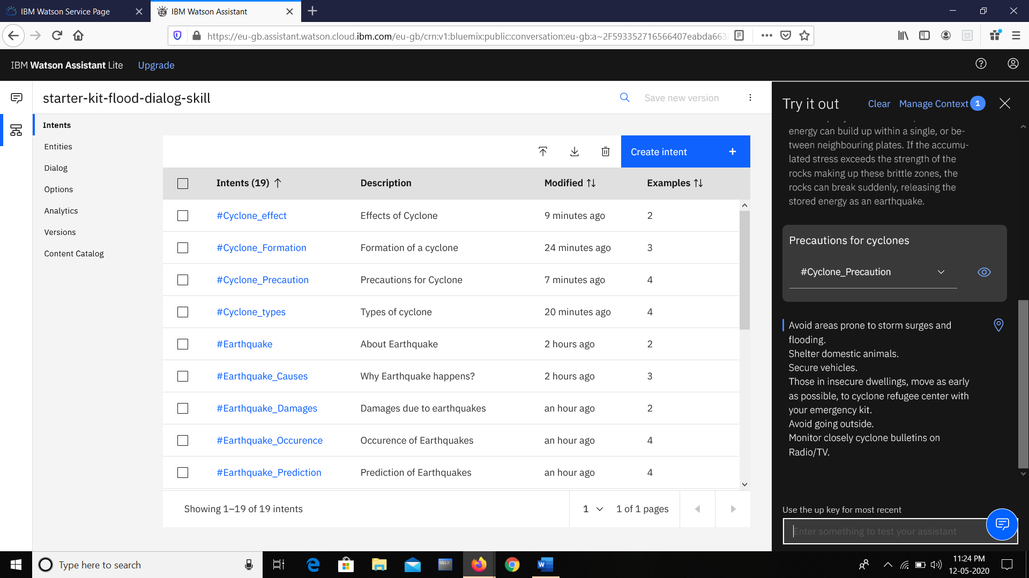

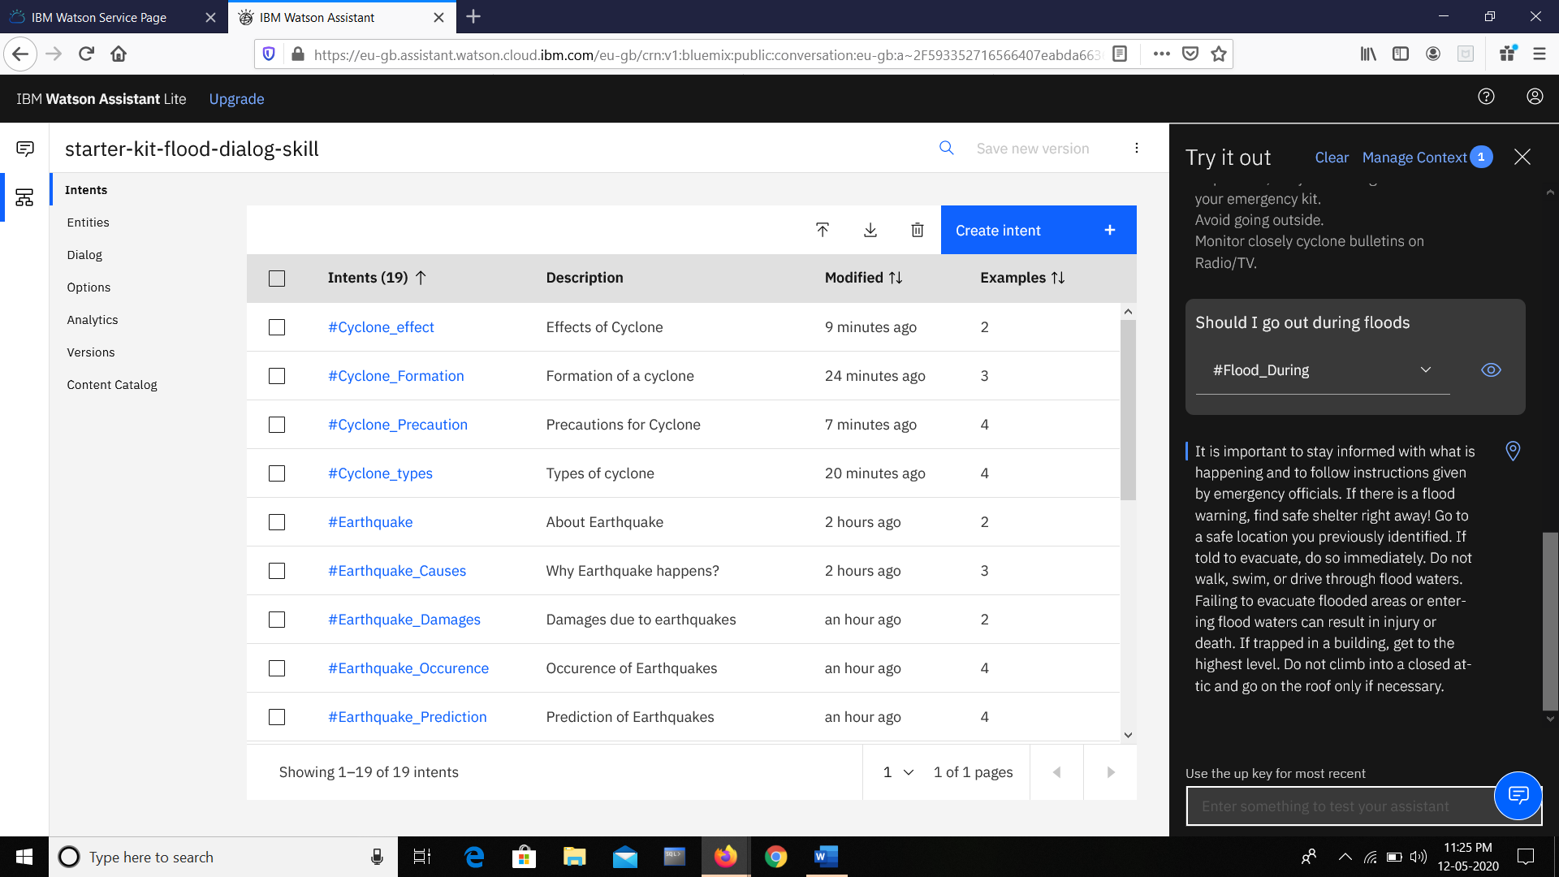
INTEGRATION OF IBM WATSON ASSISTANT WITH FACEBOOK MESSANGER:

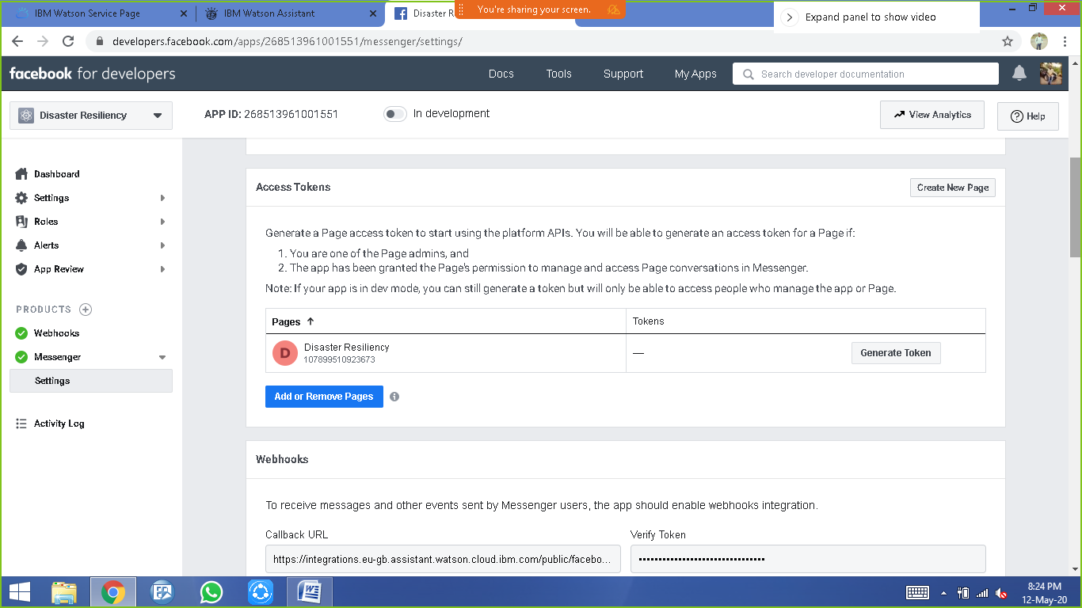

Step 1
Create a Facebook application
Go to http://developers.facebook.com and log in with your Facebook credentials. Click Add a New App and complete the steps to create a new app ID.
Note: If you have already created the app you want to use, select it from the My Apps menu.
In the navigation pane, click Settings -> Basic. Under App Secret, click Show. Copy the app secret and paste it here:

Application secret

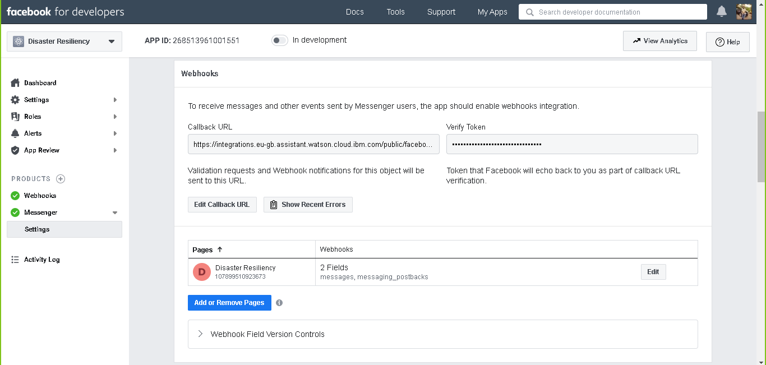

Step 2:
Connect Watson Assistant to Facebook
1. On the Facebook app page, click the plus sign (+) next to Products in the left side navigation.
2. Under Add a product, find the Messenger tile and click Set Up.
3. In the Messenger settings, scroll down to Token Generation.
Click Select a Page and choose the Facebook page you want to use for your app

Step 3:

Configure Facebook webhooks
Generate callback URL
In the Facebook Messenger settings, scroll to the Webhooks section. Click Setup Webhooks.

Step 4:

Connect your assistant
In the Messenger settings, go back to the Webhooks section and click Select a Page. Select the same page you selected in step 2, and then click Subscribe.
Note: Subscribe to only one page. Multiple-page subscriptions are not currently supported.
Congrats! You should be able to test your bot now in Messenger. You must be a Page admin to interact with it until you make it public.

Step 5:

Start app review process
Once you have confirmed your bot is working in Messenger, and you would like to make the bot public, go to https://developers.facebook.com/docs/messenger-platform/app-review/ and follow the instructions to start the app review process.

TESTING ON FACEBOOK MESSENGER:
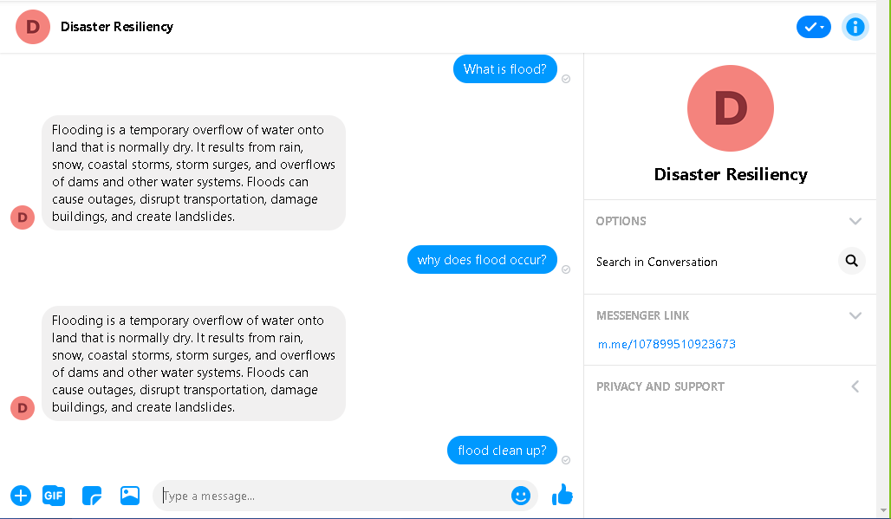

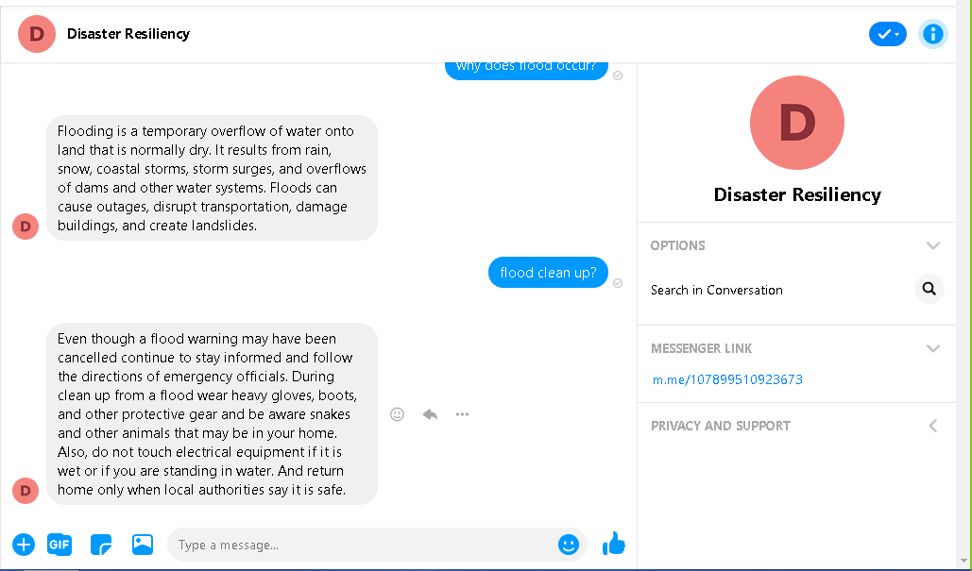

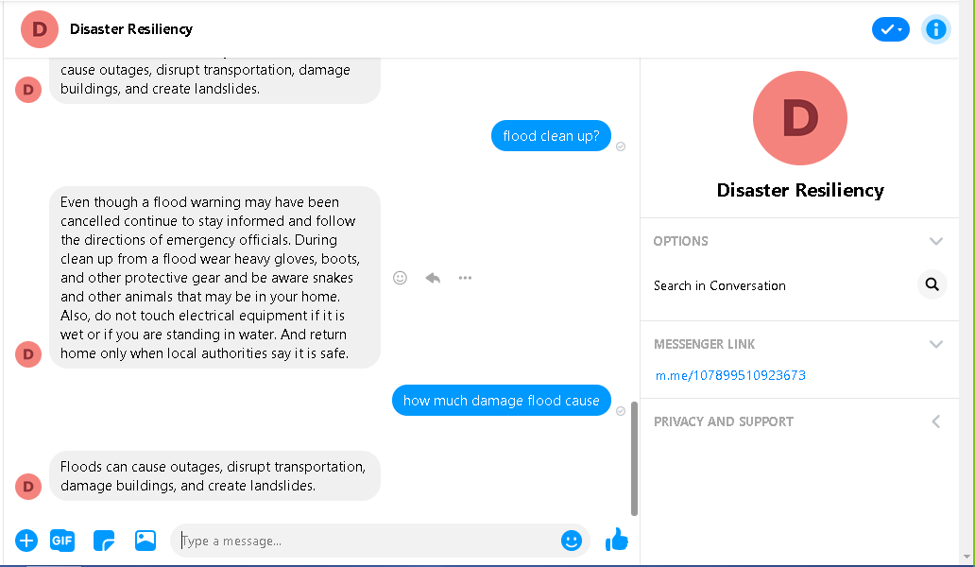

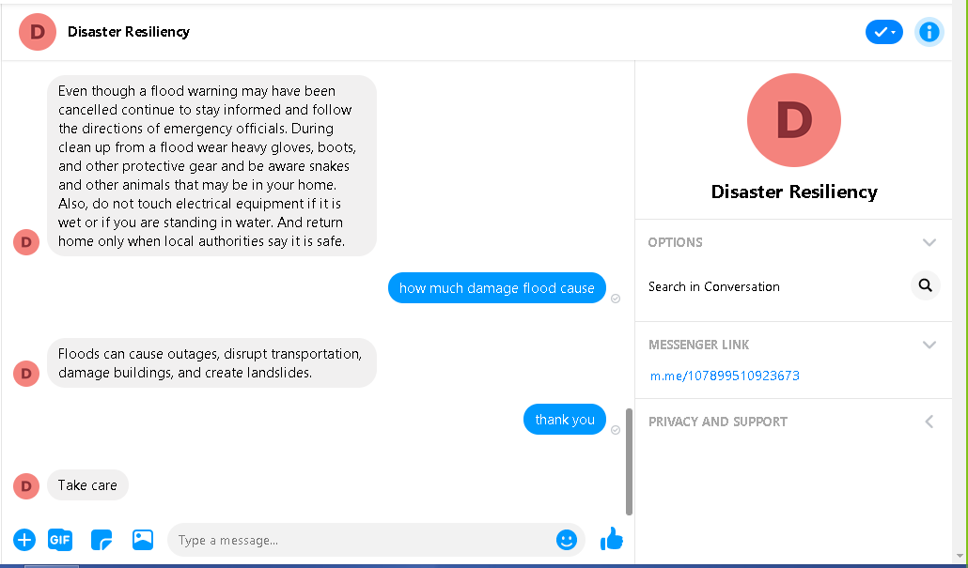

THANK YOU

